**DynamoDB – CRUD operation using Lambda function URL.**

* Lambda Function URL created.

* DynamoDB table created.

* Global Secondary Index created.

* File “helpers.mjs” (Source Code lines 1 – 24).

* File ‘helpers.mjs’ (Source Code lines 25 – 54) – ‘createNewCourse’ Method.

* File ‘helpers.mjs’ (Source Code lines 55 – 74) – ‘getCourseByField’ Method.

* File ‘helpers.mjs’ (Source Code lines 75 – 101) – ‘getCourseByFilter’ Method.

* File ‘helpers.mjs’ (Source Code lines 102 – 119) – ‘deleteCourse’ Method.

* File ‘helpers.mjs’ (Source Code lines 120 – 141) – ‘getCourseItem’ Method.

* File ‘helpers.mjs’ (Source Code lines 142 – 172) – ‘updateCourse’ Method.

* File ‘index.mjs’ updated for the POST operation.

* New Event ‘createNewCourse’ to TEST the POST operation.

* TEST execution result for POST operation.

* New record inserted in the DynamoDB table named ‘CourseTable’.

* Added few more records to the ‘CourseTable’.

* File ‘index.mjs’ updated for the GET operation (get course by courseCode & teacherName).

* Test data updated for getCourseItem.

* Result of the getCourseItem.

* File ‘index.mjs’ updated for the PUT operation.

* Test data updated for updateCourse.

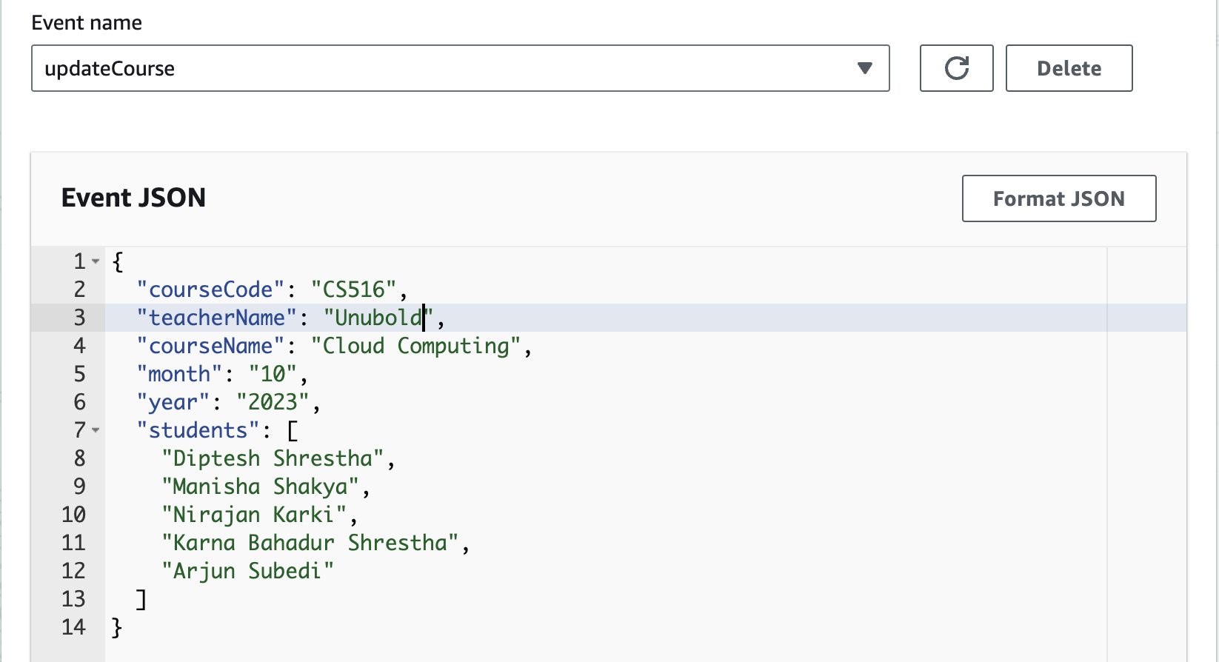

* Result of the updateCourse.

* Record updated in the ‘CourseTable’ – courseName and student’s data were updated.

* File ‘index.mjs’ updated for the GET operation (Query on index field).

* Test data updated for getCourseByField.

* Result of the getCourseByField.

* File ‘index.mjs’ updated for the DELETE operation.

* Test data updated for deleteCourse.

* Result of the deleteCourse.

* Record deleted from the ‘CourseTable’ (No more record with courseCode : CS516).

* File ‘index.mjs’ updated for the GET operation (Scan query – by filter).

* Test data updated for getCourseByFilter.

* Result of the getCourseByFilter.

